A Novel Approach to Predict Blood Group using Fingerprint Map Reading
In this paper author using Thermal Spectroscopic Photoplethysmographic (PPG) sensor fingerprint images to predict user Blood Group. Propose application extracting Gabor signals from sensor images and then utilizing Machine Learning algorithm to train all images signals. ML trained model can be employ to predict Blood Group from any sensor fingerprint images.
To train ML models we are using following group types showing in below screen
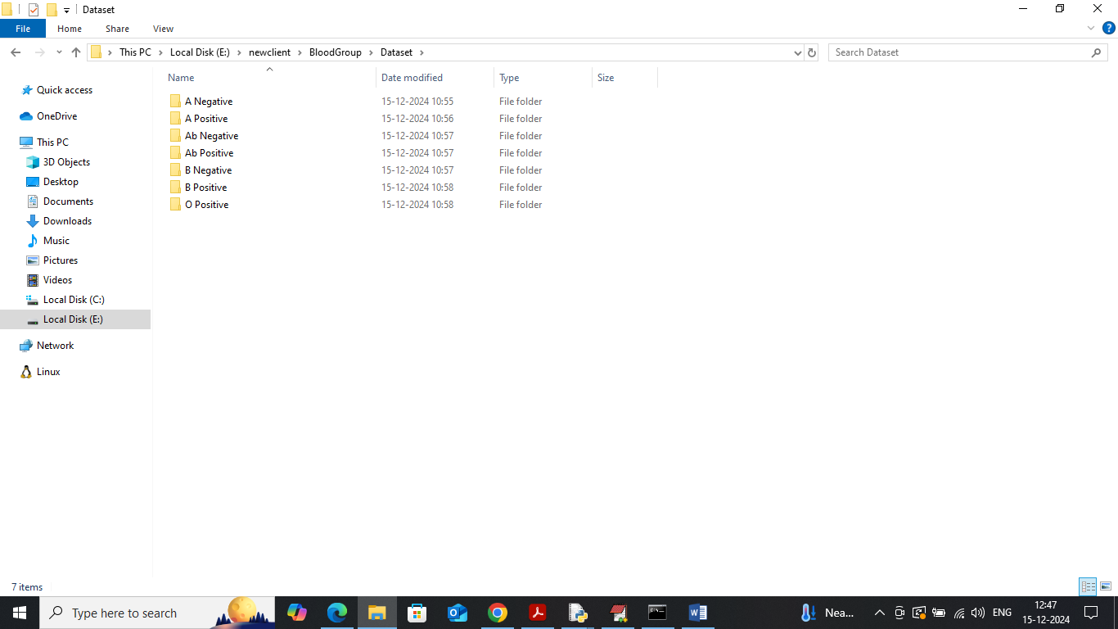
Go inside any folder to view below thermal images like below page
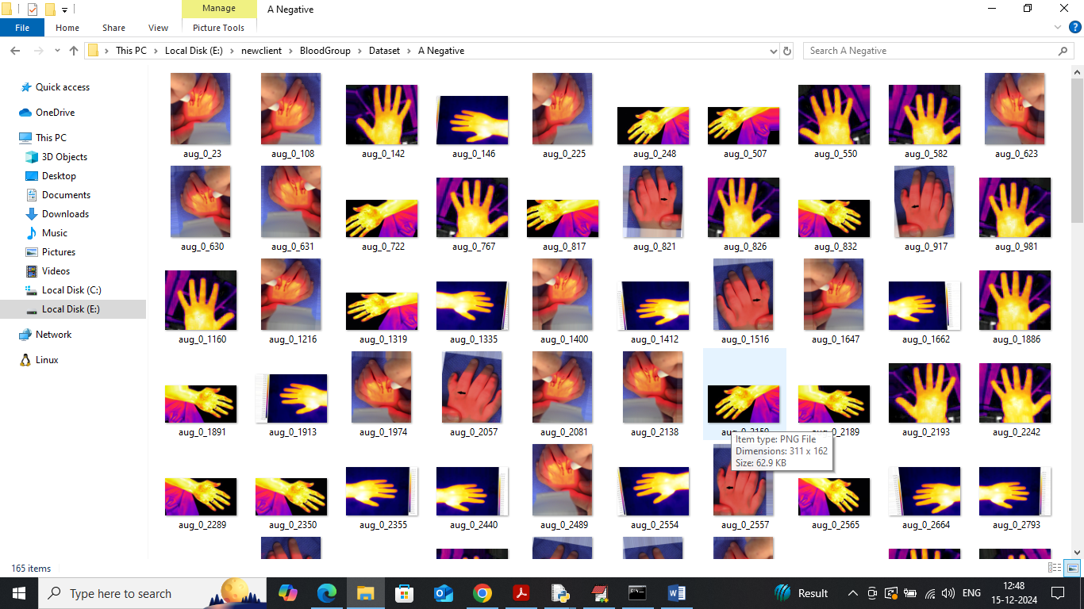
So by using above images will extract signals and train with ML model to predict Blood group
To implement this project we have designed following modules
- User Login: user can login to system using username and password as admin and admin
- Train ML Algorithm: after login user can use this module to train ML algorithm and can analyse model performance in terms of accuracy and other metrics
- Prediction: using this module user can upload test image and then application will extract Gabor signals and apply ML model to predict blood group
- Logout: can exit from the application
To run project install python3.7.2 and then install all packages given in requirements.txt file and then double click on ‘run.bat’ file to start python server and get below page
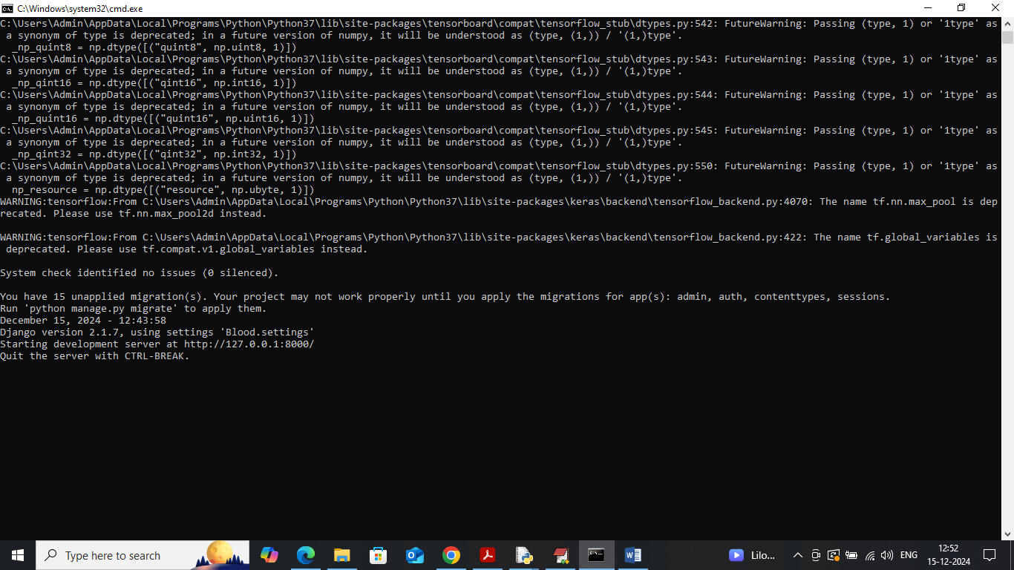
In above screen python server started and now open browser and enter URL as http://127.0.0.1:8000/index.html and then press enter key to get below page
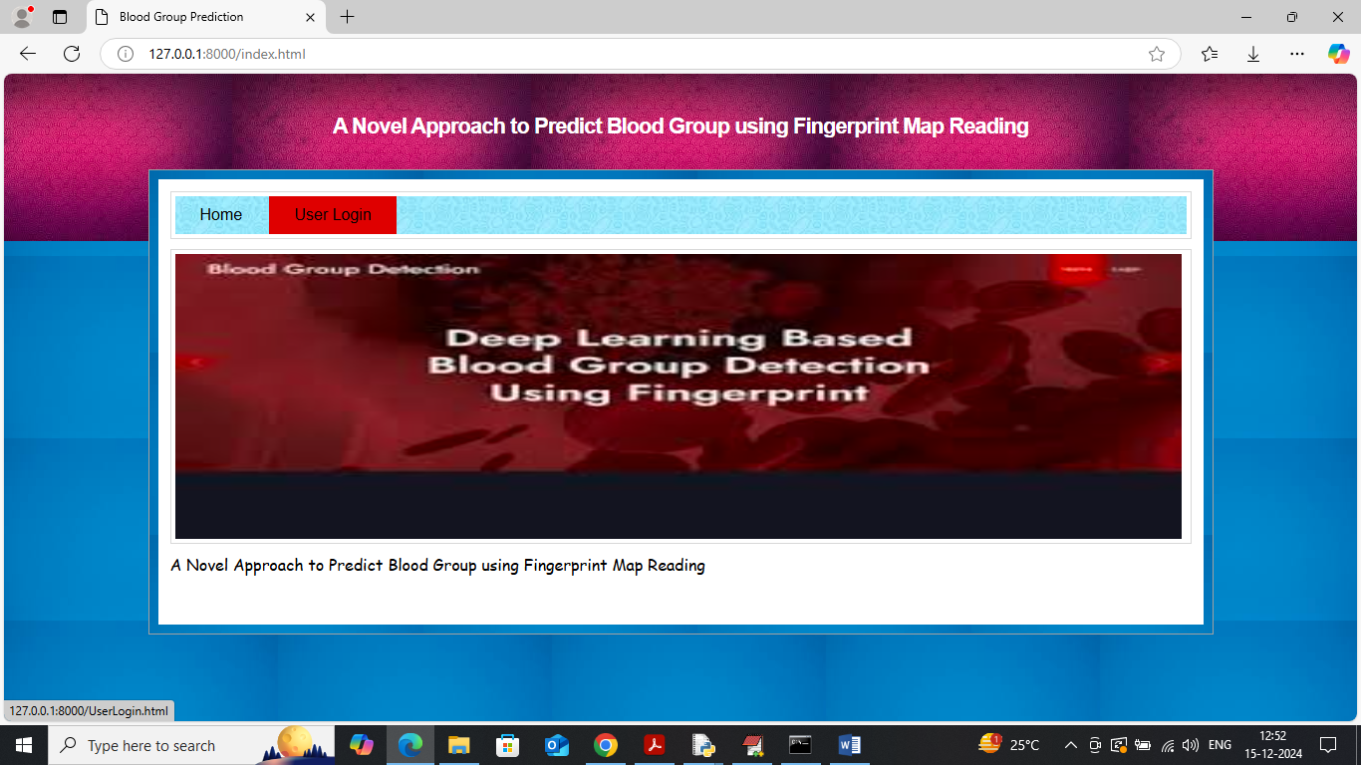
In above screen click on ‘User Login’ link to get below page
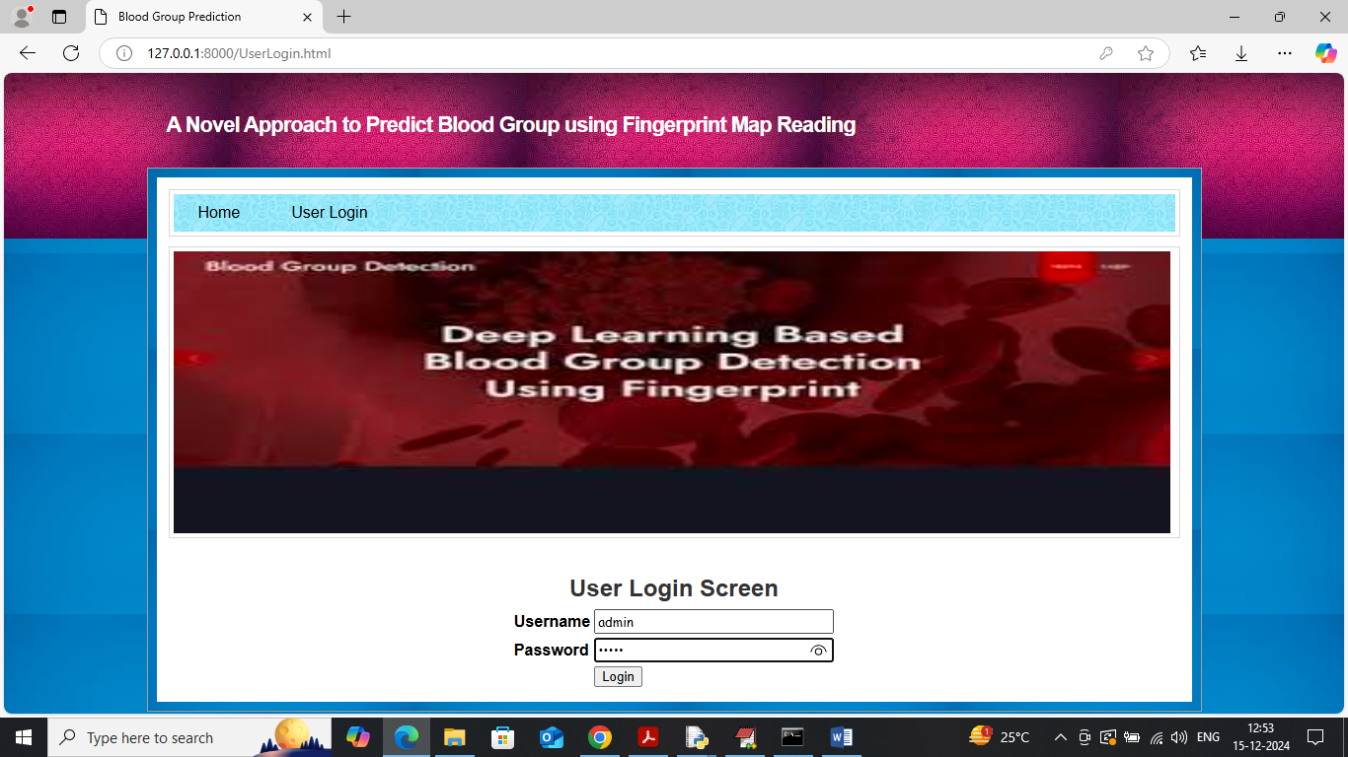
In above screen user is login and after login will get below page
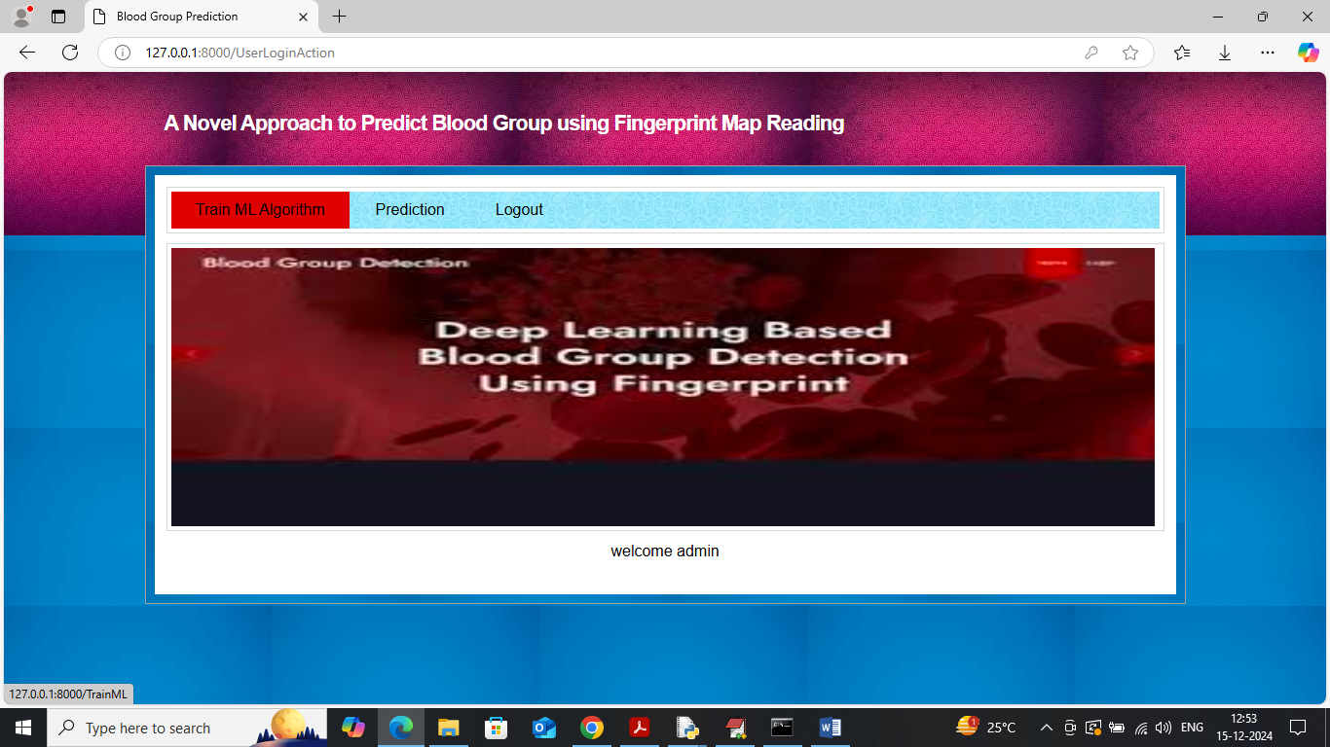
In above screen click on ‘Train ML Algorithm’ link to train model and get below page
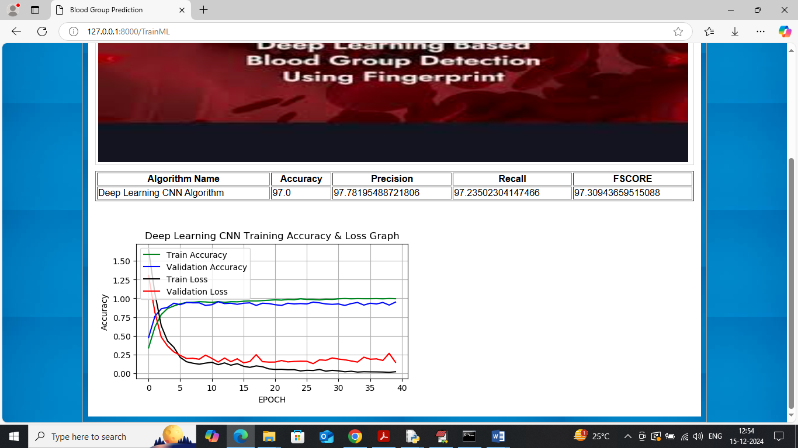
In above screen ML CNN model got 97% accuracy on test data prediction and can see other metrics like precision, recall and FSCORE. In above screen visualizing ML CNN training accuracy and loss graph where x-axis represents training EPOCH and y-axis represents accuracy and loss values. In above graph blue and green line represents training and validation accuracy and then red and black line represents training and validation loss. In above graph can see with each increasing epoch accuracy got increased and reached closer to 1 and loss got decreased and reached closer to 0. Now click on ‘Prediction’ link to get below page
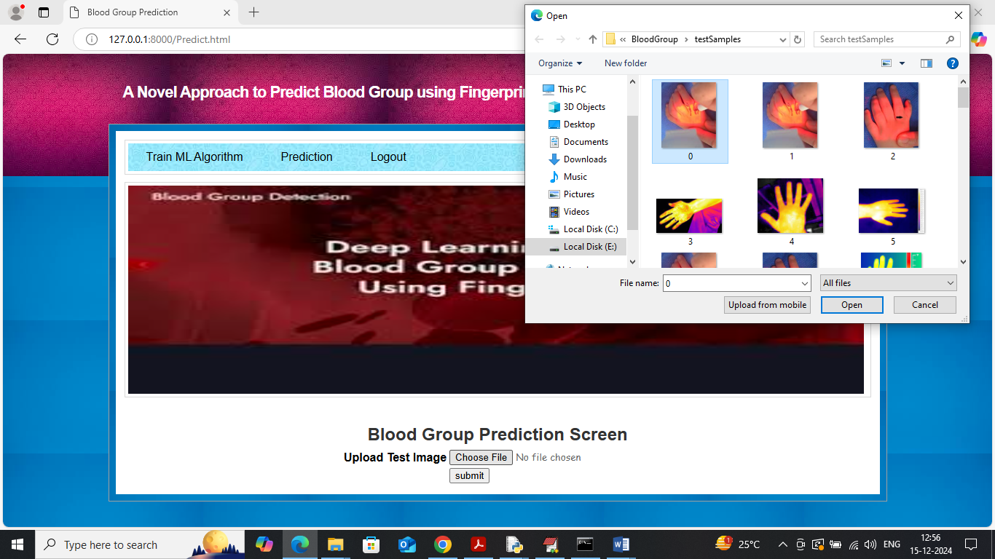
In above screen selecting and uploading test image and then click on “open and submit’ button to get below output
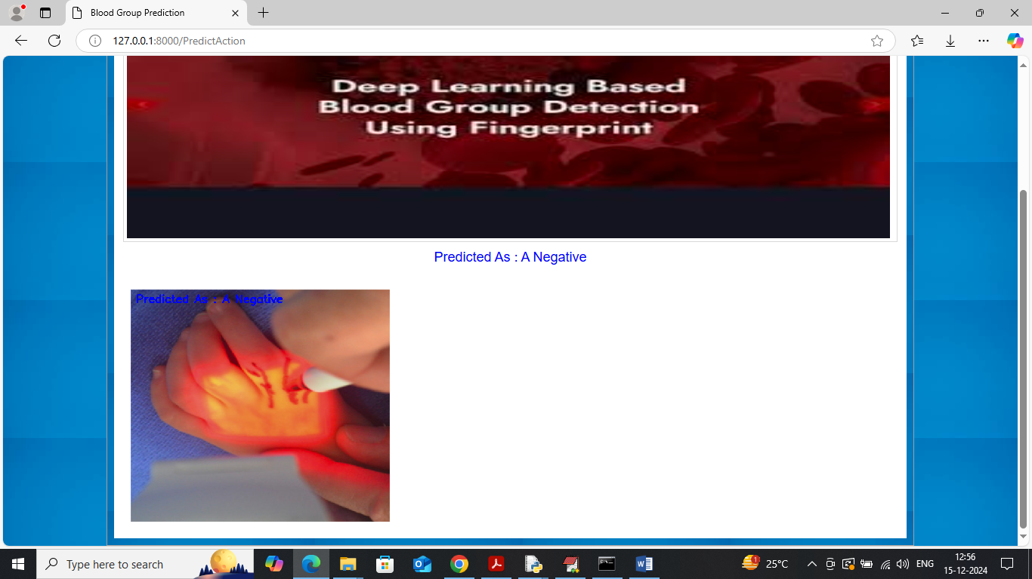
In above screen uploaded image is predicted as ‘A Negative’ blood group and below is testing another image
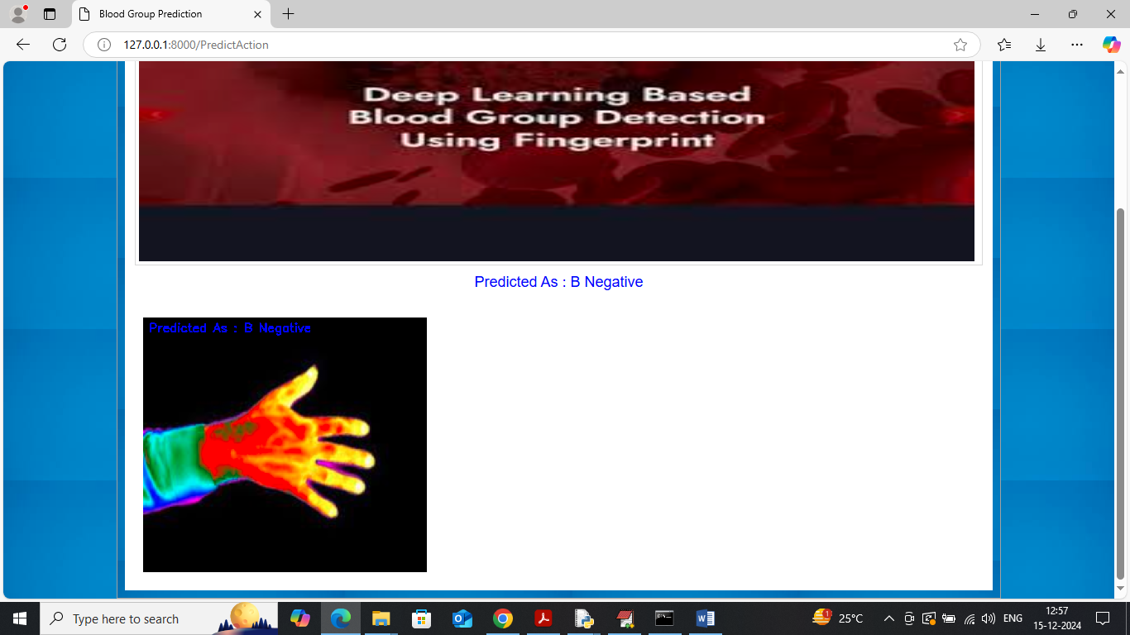
Above image predicted as B Negative
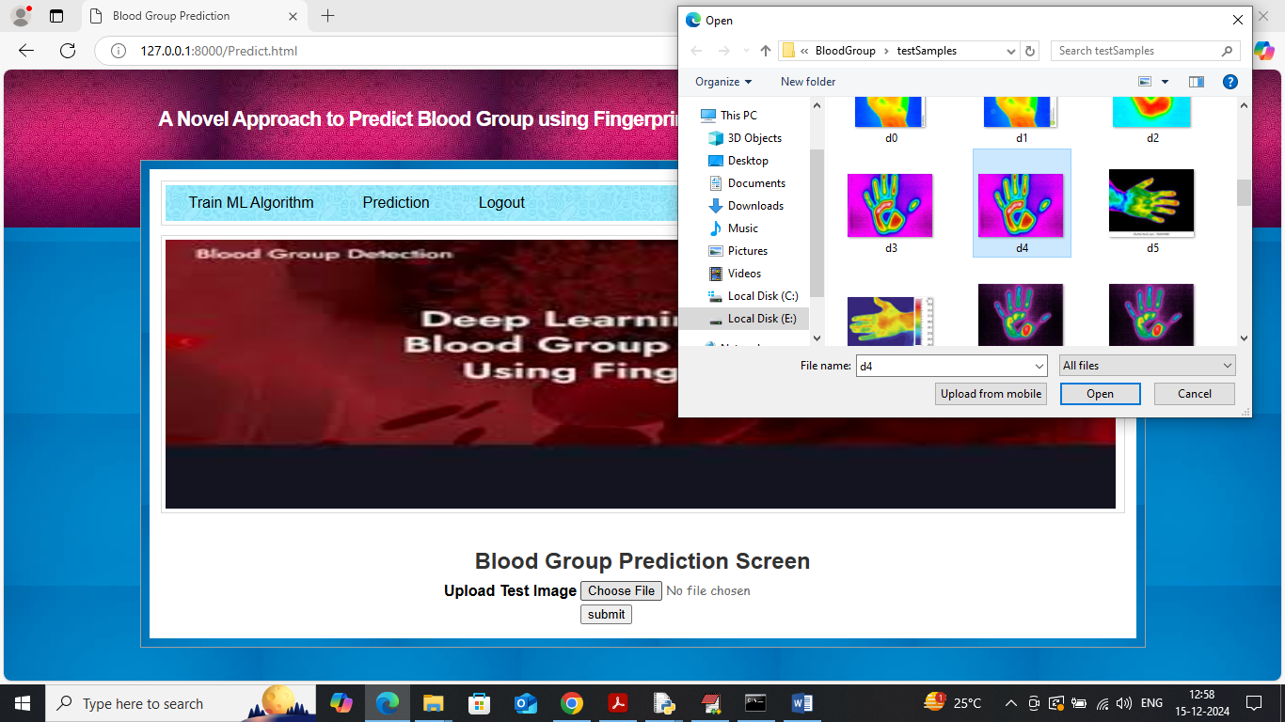
In above screen uploading another image and below is the output
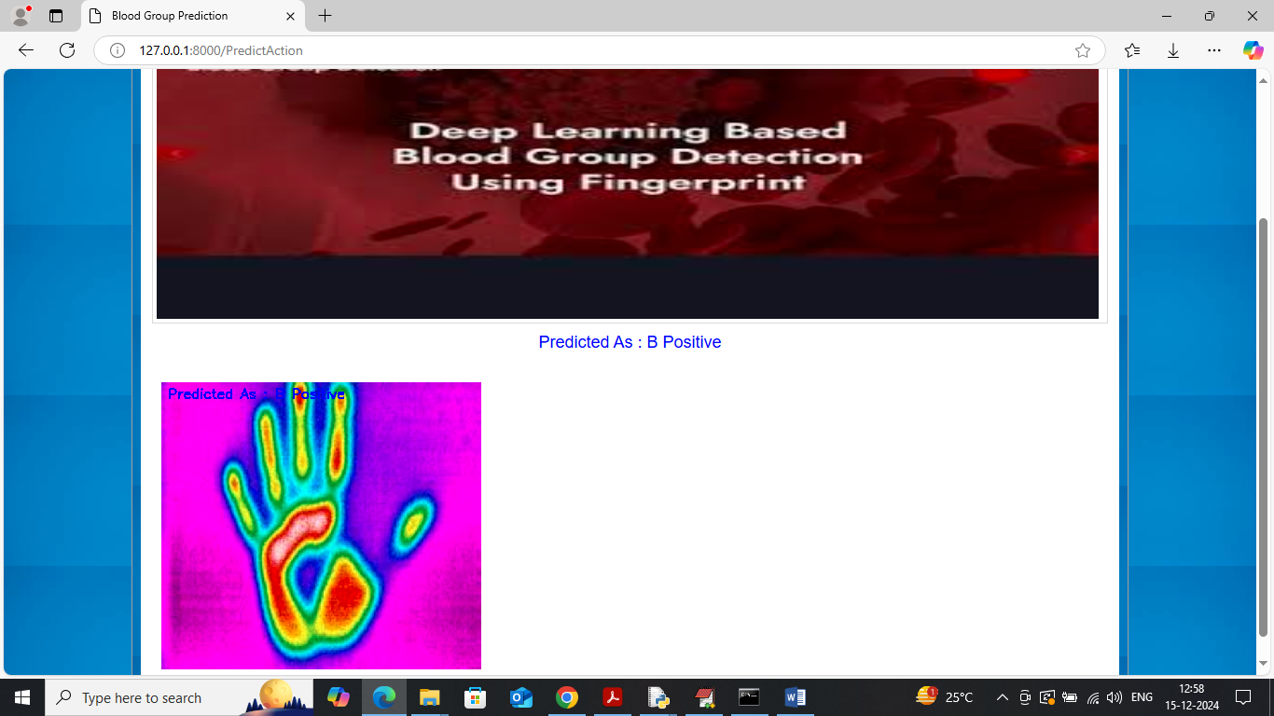
Above prediction is B Positive
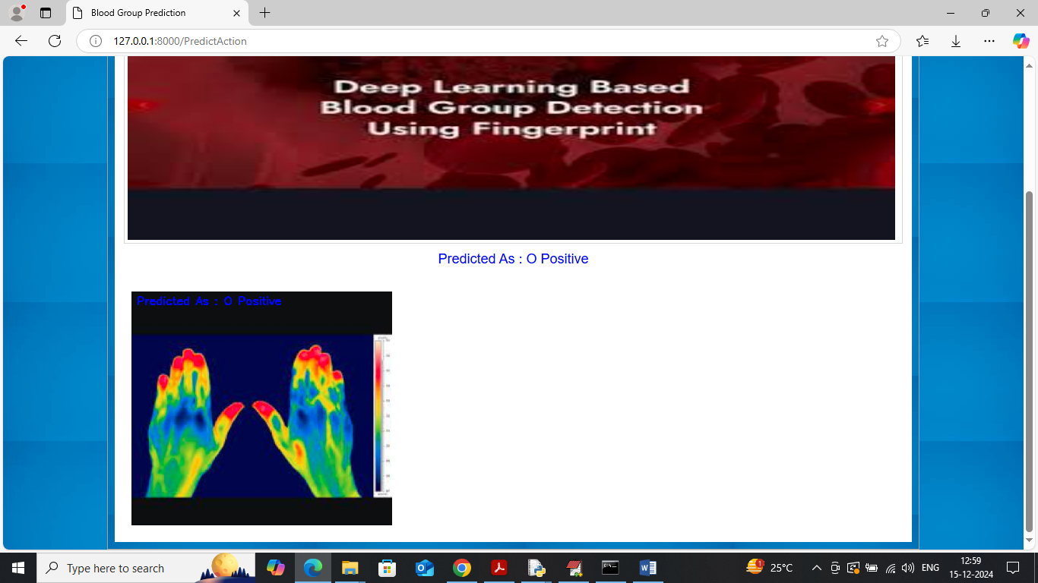
Above image predicted as ‘O Positive’.
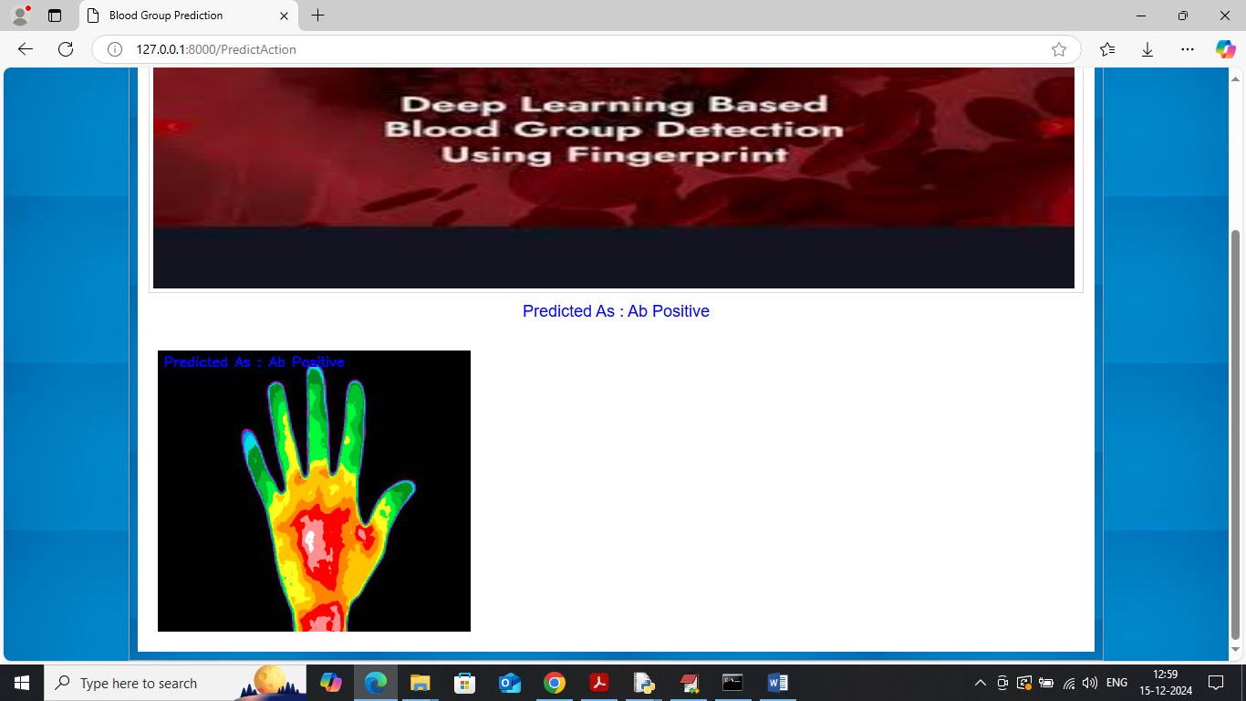
Above image is AB positive
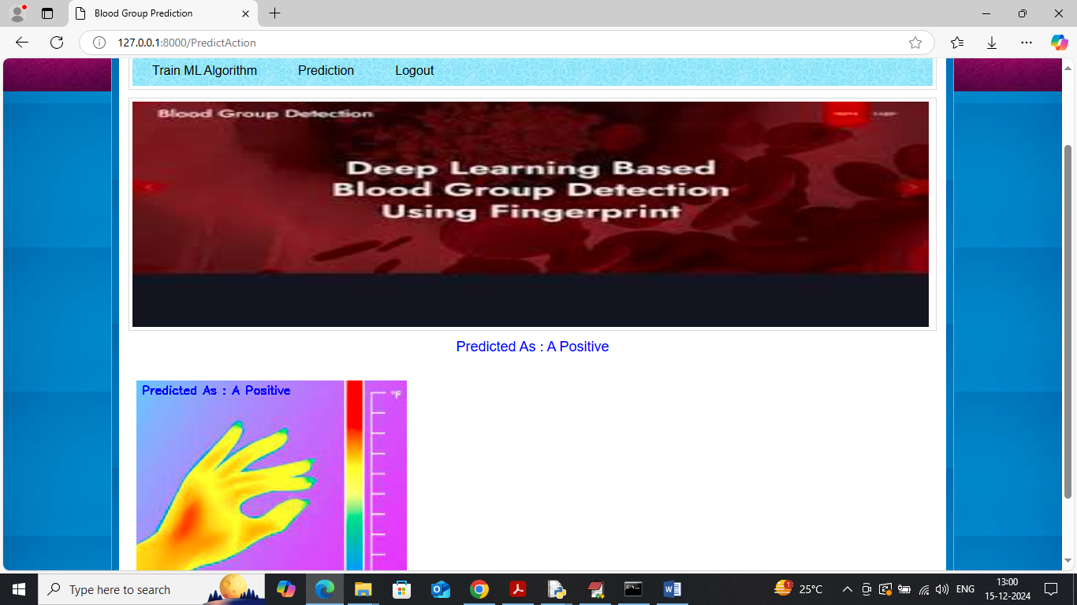
Above image is A Positive
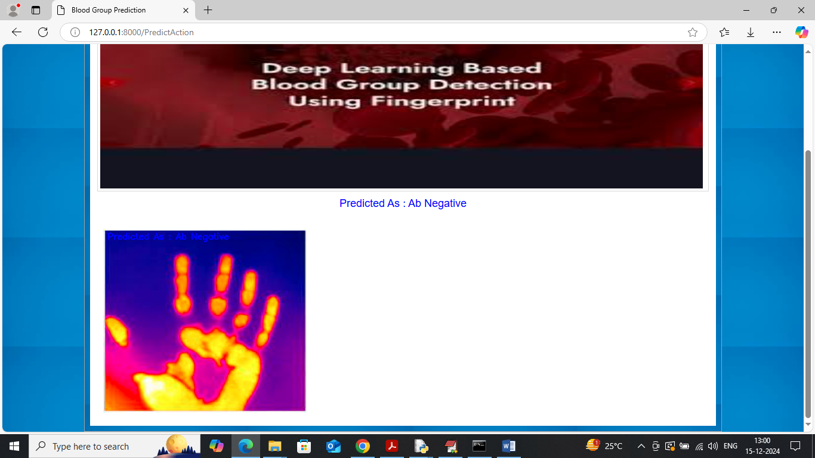
Above image is AB negative.
Similarly you can test other images and in ‘test Images’ folder we kept nearly 60 test images.

